Aura Academy Project Report

Subject : Web Technology with UI/UX

Group Members :

- Neev Tamboli
Enrollment No: 2401031800128
Batch : C1
- Prins Jadav
Enrollment No: 2401031800142
Batch : C1
- Ruchit Chauhan
Enrollment No: 2401031830022
Batch : C2
- Mihir Shah
Enrollment No: 2401031830031
Batch : C2
- Khushi Shah
Enrollment No: 2401031830042
Batch : C3
- Urva Dave
Enrollment No: 2501031830024
Batch : C3

Semester: 4

- Introduction

Aura Academy is an AI-powered coding tutor platform designed to provide an interactive and modern learning experience. This project focuses on UI/UX design and web development using modern tools.

- Task Implementation

Task 1:
- Created GitHub repository using enrollment number
- Created two folders: Figma and Code
- Uploaded files in respective folders

Task 2:
- Designed prototype in Figma
- Created 8+ screens including Login, Dashboard, Quiz, Chat, Profile, etc.

Task 3:
- Developed website using:
  - HTML
  - CSS
  - JavaScript
  - jQuery
  - Bootstrap

Task 4:
- Uploaded all code files into GitHub Code folder

- GitHub & Figma Links

GitHub Repository: https://github.com/Khushi2016/2401031830042.git

Figma Design:
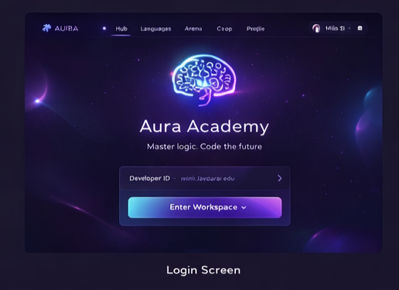

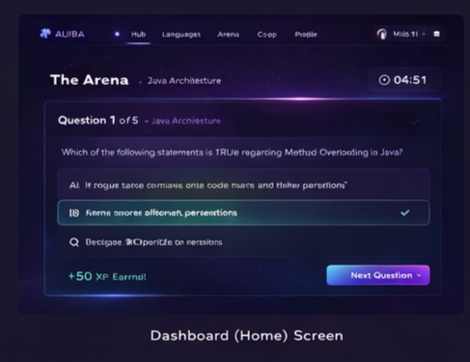
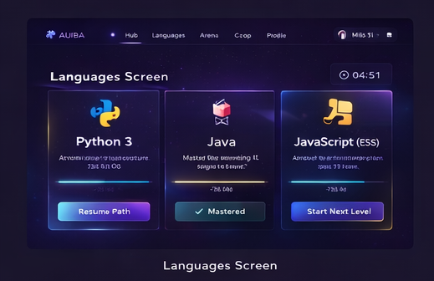
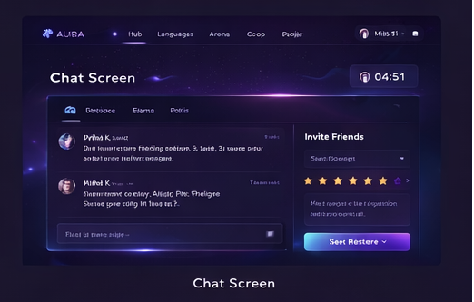
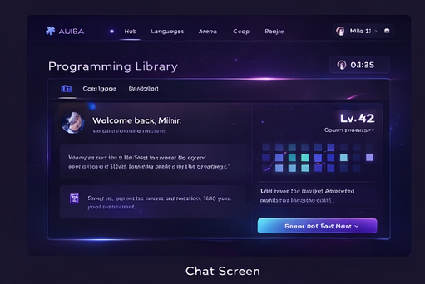

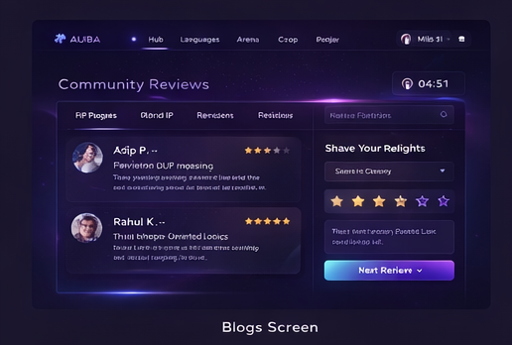

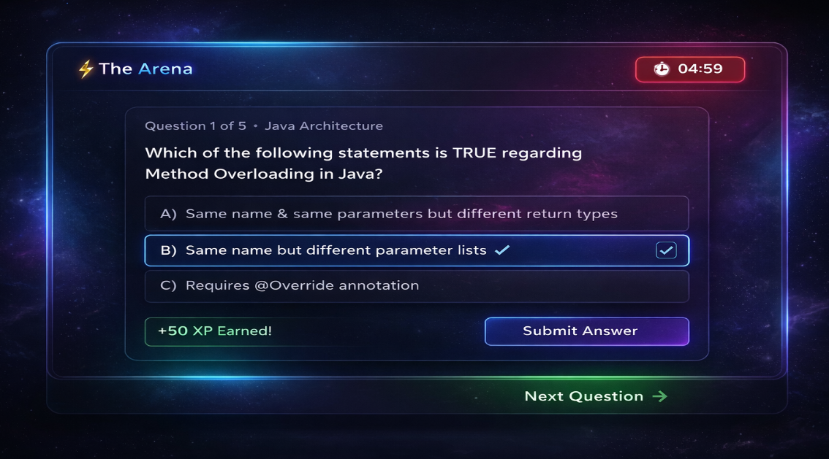

- Conclusion

This project demonstrates the complete workflow from designing UI in Figma to developing a functional website using modern web technologies. It enhances practical knowledge of UI/UX and frontend development.

